**STAT 351 – Homework 3  - Due by 11.59 pm on Thursday, April 22**

**You are encouraged to work on this assignment in groups. However, you cannot write exactly same explanations.**

**If I see the exact same explanation on two or more assignments, then I’ll give zero points for those assignments.**

**Show your work before the final answer to get full points.**

**Problem 1:**

Eighty percent of the light aircrafts that disappear while in flight in a certain country are subsequently discovered.

Of the aircrafts that are discovered, 75% have an emergency locator, whereas 80% of the aircrafts not discovered do not have such a locator.

Suppose a light aircraft has disappeared.

a) What is the probability that it will not be discovered and has an emergency locator?

b) What is the probability that it has an emergency locator?

c) If we know that it has an emergency locator, then what is the probability that it will be discovered?

d) Do you think discovering an aircraft is statistically independent from having an emergency locator? Provide reasons (probabilities).

**Problem 2:**

Three radar sets, operating independently, are set to detect any aircraft flying through a certain area.

Each set has a probability of 0.95 to detect a plane in its area. If an aircraft enters the area,

(a) compute the probability that it is detected by all three radar sets?

(b) compute the probability that it is detected by the 2nd radar set and not detected by 1st and 3rd radar set?

**Problem 3:** For A, B independent events, P(A|B) = 0.3, P(B) = 0.8.

(a) Compute P(A)

(b) Compute P(Ac U B)

**Problem 4:**

As shown below, a system is composed of 4 identical components, each one of which is operational with probability λ, independent of the other components.

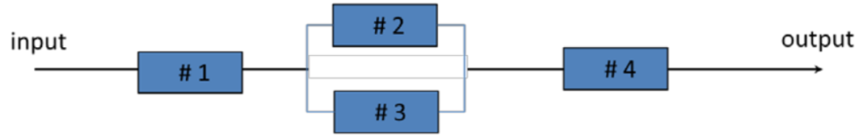

The system is operational if there is a path from input to output.

(a) Compute the probability that system is operational. **Your answer must be a function of λ**.

(b) If λ = 0.6, then compute the probability that the system is operational. Your answer has to be a number.

**Problem 5:**

A modem transmits a **+2-voltage signal** into a channel.

The channel adds to this signal a **noise term** that is selected from the set {0, -1, -2, -3} with respective probabilities {4/10, 3/10, 2/10, 1/10}

Let the **output** of the channel is denoted by random variable **X**. (Note; Output = Signal + Noise)

(a) Write the **pmf of X** using a table or formula. (You must list all the possible values of X and their corresponding probabilities)

(b) What is the probability that the output of the channel is equal to the input signal of the channel?

(c) What is the probability that the output of the channel is less than zero?

(d) Use the pmf of X you created in part (a), and compute the **expected output** of the channel **using the definition** of expected value. **Show your work**. **No MATLAB use here**.

(e) Compute variance and standard deviation of the **output** of the channel **using one of the formulas** learned in the class. **Show work. No MATLAB use here.**

**Problem 6:**

The following **MATLAB code** shows how to compute expected value, variance and standard deviation of a discrete random variable using the pmf.

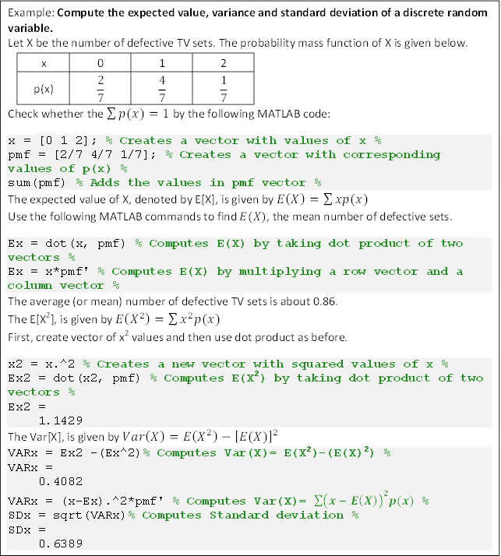

Consider the following pmf of the random variable X which gives the number of available channels in TDMA (Time Division Multiple access) wireless system:

|  |  |  |  |
| --- | --- | --- | --- |
| x | 0 | 1 | 2 |
| P(x) | 0.0625 | 0.3125 | 0.625 |

Edit the above code or write a similar code in MATLAB to compute the following.

**Use MATLAB to compute the following.**

(a) Use the given pmf of X and compute the expected number of available channels using MATLAB. **Report your final answer with all the decimal places here. (Do not report MATLAB code here)**

(b) Compute variance and standard deviation of the number of available channels using MATLAB. **Report your final answers with 4 decimal places here. (Do not report MATLAB code here)**

(c) Report your complete MATLAB code here. (Do not report MATLAB output here)